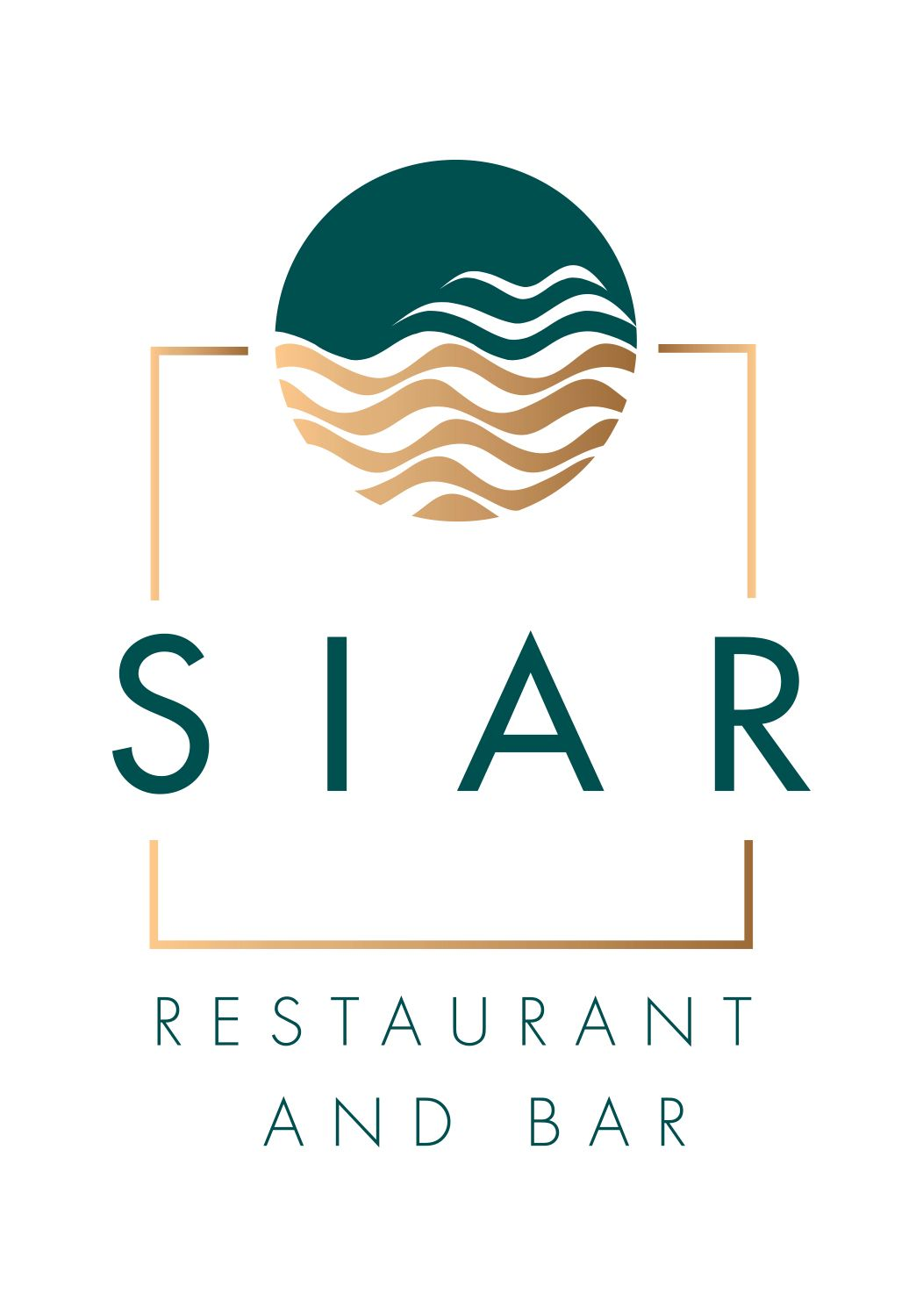

**Welcome to Sunday Lunch at SIAR Restaurant**

**APPETISERS**

Homemade Soup of the Day €7.50

(Contains: Milk, Celery)

Buttermilk Fried Chicken Caesar Salad, €10.50

Cherry Tomatoes Parmesan Shavings, Garlic Croutons

(Contains: Milk, Sulphites, Wheat, Eggs, Mustard, Fish, Celery)

Goats Cheese, Honey & Thyme Croquettes €12.00

Toasted Almonds, Pea Puree, Pickled Radish, Arugula

(Contains: Milk, Sulphites, Mustard, Wheat, Egg, Nuts; Almonds, Hazelnuts, Pinenuts)

Harissa & Lime Prawn Cocktail €11.00

Baby Gem Lettuce, Avocado, Cherry Tomatoes

(Contains: Milk, Crustaceans, Sulphites, Mustard, Soya)

Atlantic Seafood Chowder €9.00

(Milk, Sulphites, Fish, Crustaceans, Mollusks, Celery)

**MAIN COURSES**

Roast Irish Beef, Roast Garlic Potatoes, Braised Red Cabbage, Yorkshire Pudding €22.00

(Contains: Milk, Sulphites)

Roast Leg of Irish Lamb, Potato Gratin, Maple Roasted Parsnips €22.00

(Milk, Celeriac, Sulphites)

Pan Seared Irish Chicken Supreme*,* Creamed Kale, Carrot Puree €21.00

(Contains: Milk, Wheat, Sulphites)

Grilled Fillet of Salmon, Smoked Bacon & Peas, Chive Beurre Blanc €22.00

(Contains Milk, Sulphites, Fish)

Deep Fried Fillet of Cod Craft Beer & Herb Batter, Tartar Sauce, French Fries €18.00

(Contains: Wheat, Milk, Fish, Mustard, Sulphites)

Homemade Beef or Cajun Chicken Burger €18.00

Toasted Brioche Bun, Smoked Bacon, Applewood Cheese, Thousand Island Dressing

(Contains: Milk, Sulphites, Wheat, Mustard, Eggs, Celery)

Vegan Thai Red Roast Vegetable Curry*,* Basmati Rice, Naan Bread €18.00

Add Chicken €3.00 | Add King Prawns €4.00

(Contains: Sulphites, Wheat)

**DESSERT**

Classic Tiramisu €7.50

(Contains: Wheat, Sulphites, Egg, Milk, Soya)

Warm Chocolate & Hazelnut Brownie €7.50

[Contains: Milk, Eggs, Wheat, Soya)

Cheesecake of The Day €7.50

(Contains Wheat, Milk, Eggs, Nuts: Hazelnuts, Almonds)

Warm Apple & Rhubarb Crumble €7.50

(Contains: Milk, Eggs, Wheat, Sulphites, Nuts: Hazelnuts, Almonds)